**Project Setup & Architecture: TalentFlow AI**

**1. Defined Problem Statement**

Recruitment is one of the most resource-intensive processes in human resource management. Traditional hiring involves manually screening hundreds of resumes, writing job descriptions, and conducting repetitive first-round interviews all of which consume significant recruiter time and introduce potential bias.

Problem:  
Current recruitment systems lack automation and intelligence in screening, evaluating, and shortlisting candidates efficiently. Recruiters struggle to:

* Quickly identify the best-fit candidates from large resume pools
* Generate tailored job descriptions that align with company tone and needs
* Conduct unbiased, scalable preliminary interviews

Proposed Solution – TalentFlow AI:  
TalentFlow AI is an AI-powered recruitment automation system designed to optimize the hiring process by integrating intelligent modules for:

* Automated resume screening using AI-based matching
* AI-generated job descriptions using GPT models
* AI-conducted interviews for objective evaluation
* Role-based dashboards for recruiters, admins, and candidates
* Secure MongoDB-based authentication with both persistent and temporary accounts

This solution aims to significantly reduce manual effort, improve hiring accuracy, and enhance candidate experience.

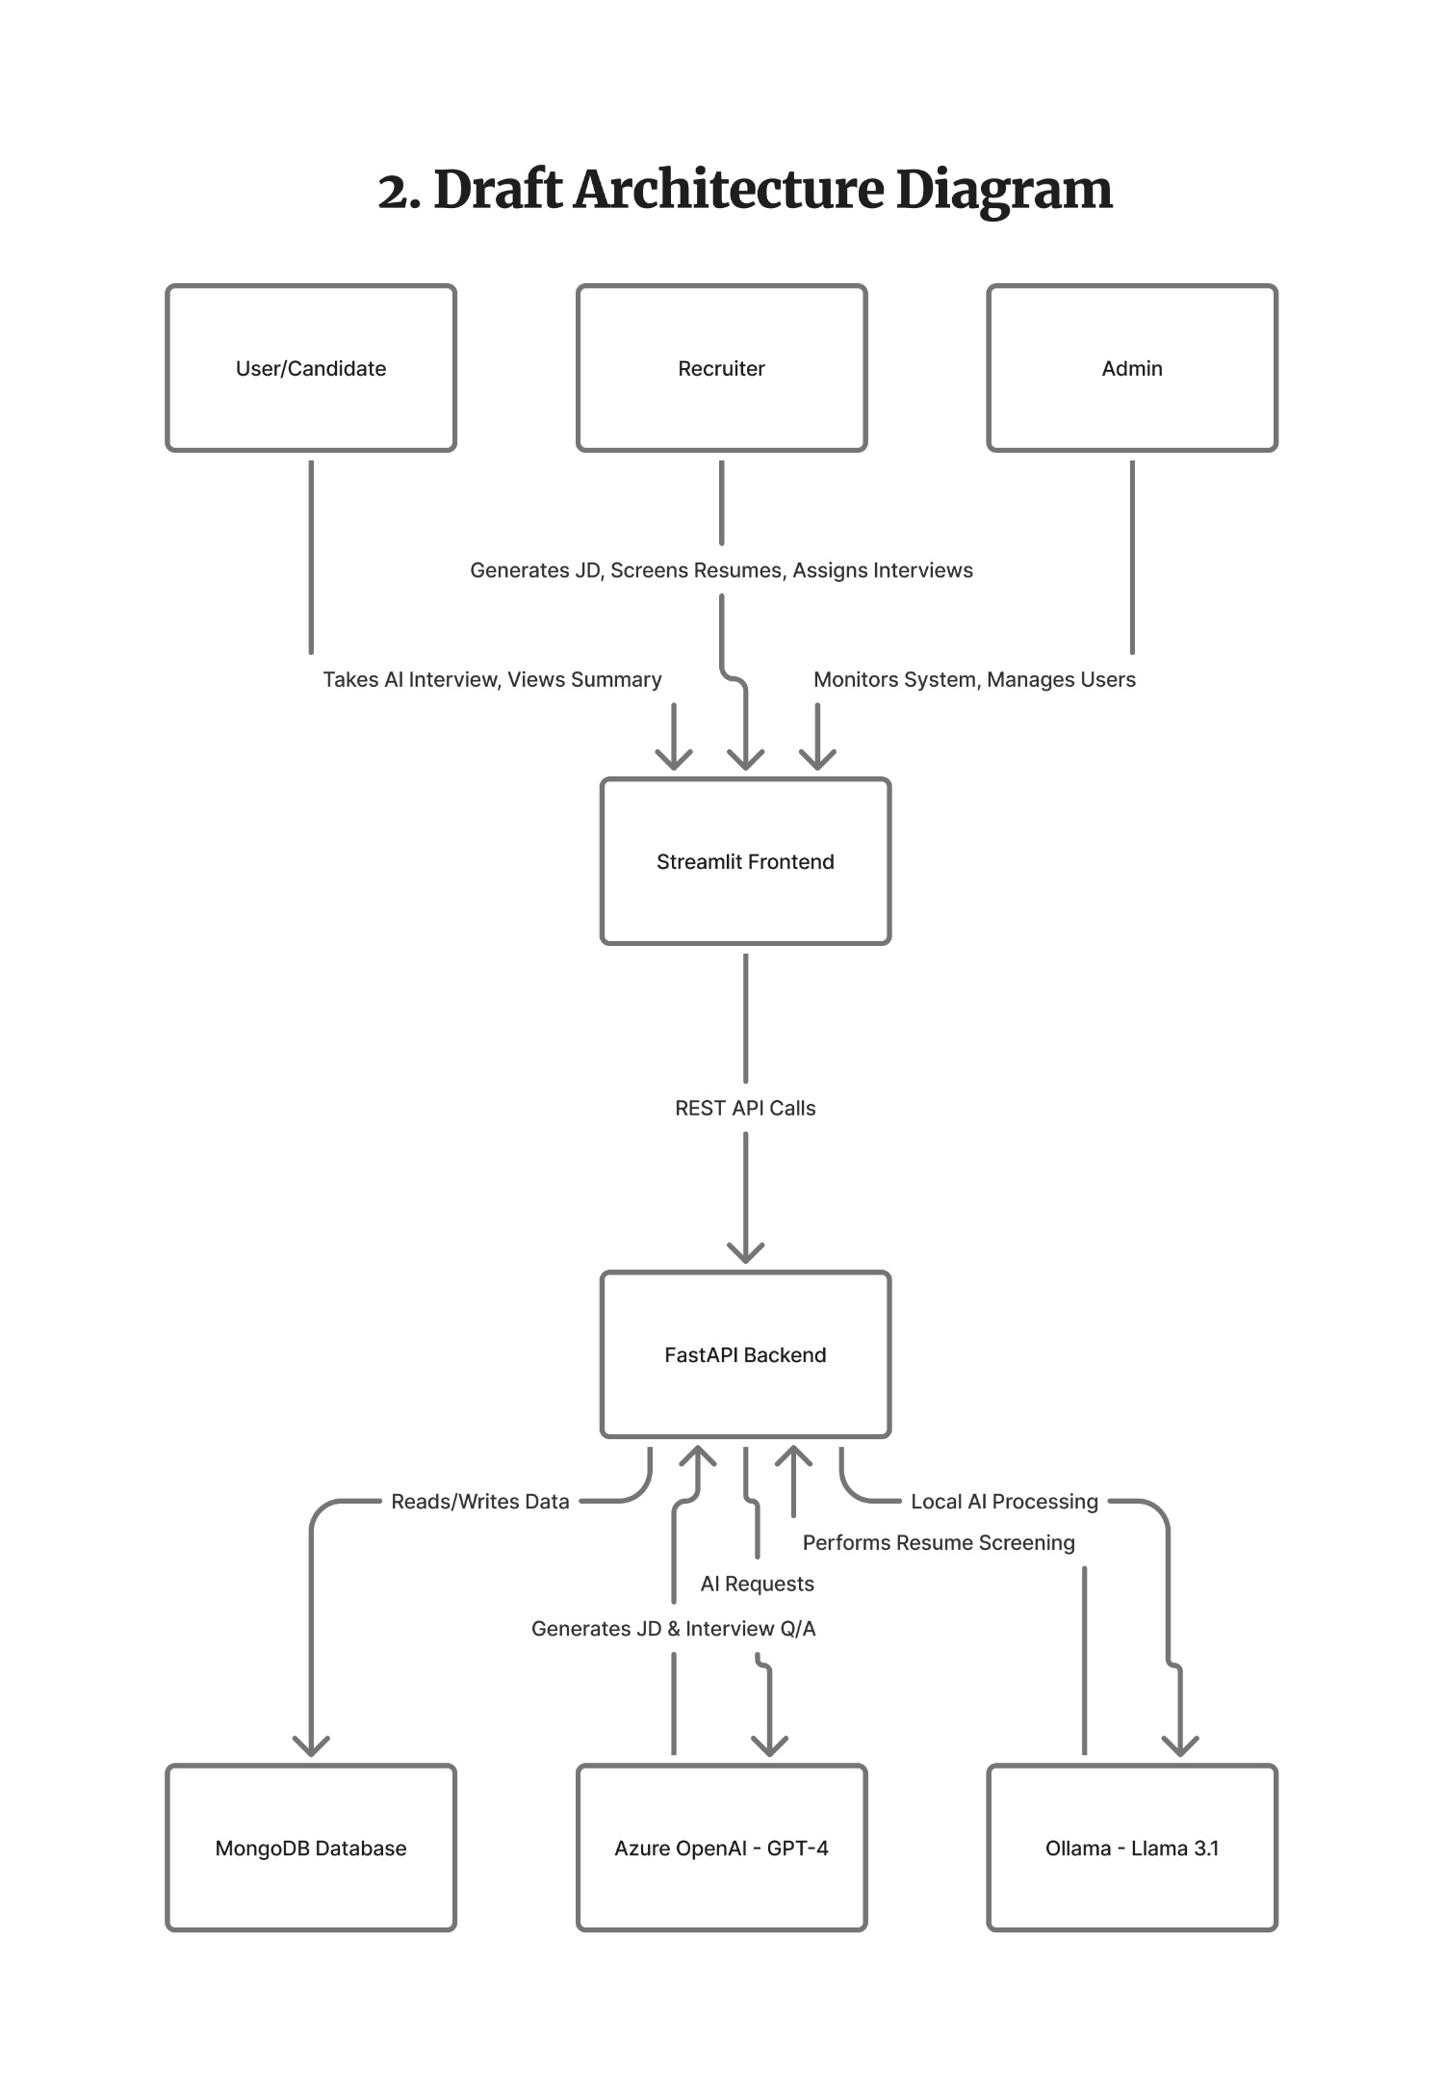**3. Finalized Technology Stack**

| Component | Technology | Justification |
| --- | --- | --- |
| Frontend | Streamlit | Provides an intuitive and rapid way to build interactive dashboards and web apps for recruiters, admins, and candidates without heavy frontend frameworks. |
| Backend Framework | FastAPI | Modern, high-performance Python web framework ideal for asynchronous I/O, scalable APIs, and built-in automatic API documentation. |
| Database | MongoDB | NoSQL database suitable for flexible document-based storage of resumes, JDs, and interview records; handles dynamic schema well. |
| AI Model – JD & Interview | Azure OpenAI (GPT-4) | Used for generating job descriptions, interview questions, and evaluating responses, ensuring enterprise-grade reliability and compliance. |
| AI Model – Resume Screening | Ollama (Llama 3.1) | Local LLM for privacy-preserving resume analysis and matching, reducing dependency on cloud APIs. |
| AI Orchestration | LangChain & LangGraph | Simplifies building modular and stateful AI workflows, especially for interviews and AI-based reasoning. |
| Authentication & Security | Bcrypt + MongoDB Auth System | Provides encrypted password storage and supports temporary candidate accounts for secure and role-based access. |
| Speech Services | Azure Whisper + Azure Speech Services | Adds voice-based question-answer capability for AI interviews. |
| Containerization | Docker | Encapsulates the backend, frontend, and dependencies into isolated containers for consistent deployment across environments. |
| Orchestration | Docker Compose | Simplifies multi-container deployment (FastAPI, Streamlit, MongoDB) with a single configuration file, enabling easy scalability and local setup. |